**Point of Sales System**

**Members:**

* Hadji Abdulmadid
* Capiral
* Gordo
* Mila
* Podiotan

**Class Diagram**

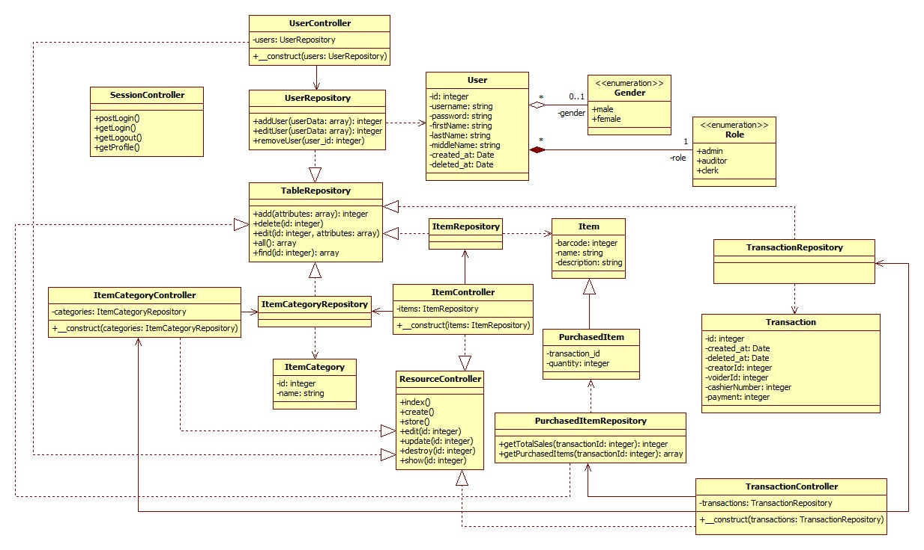

**Use Case Diagram**

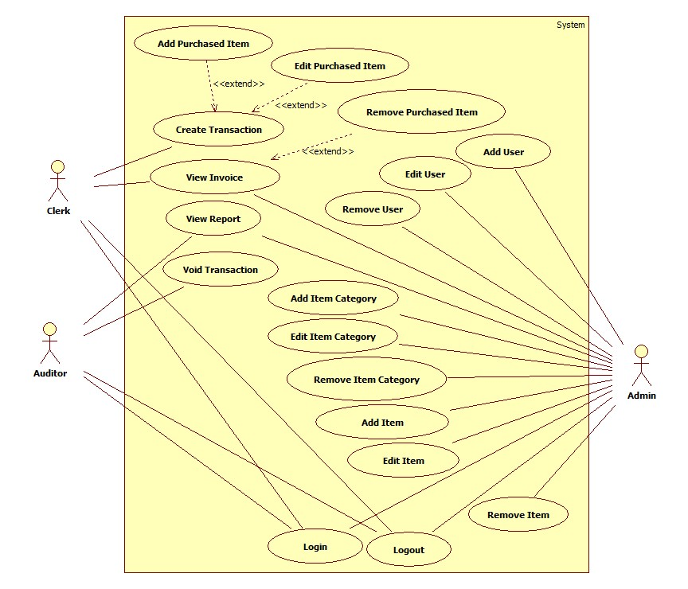

**Sequence Diagram**

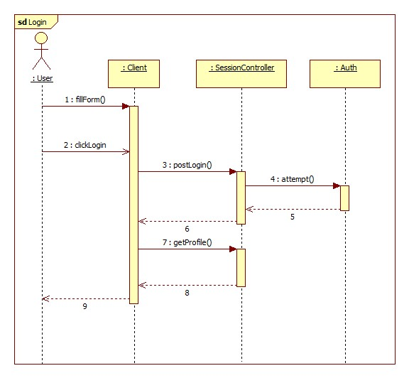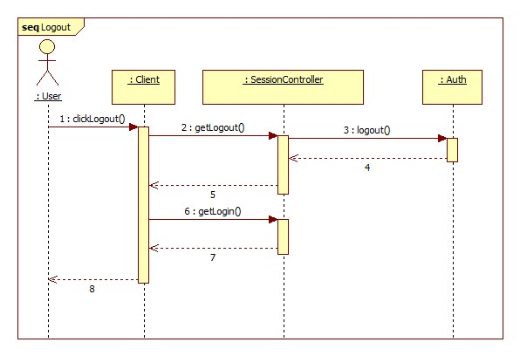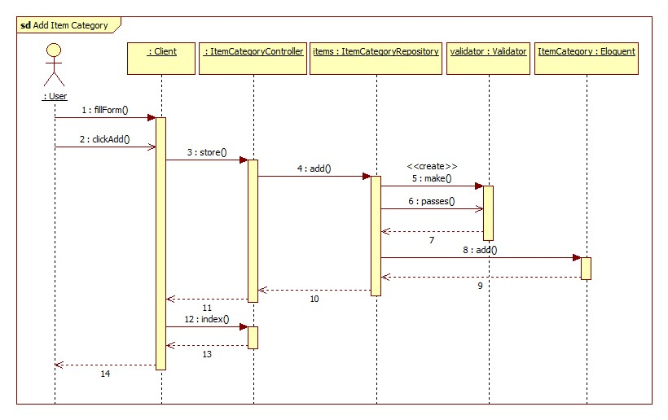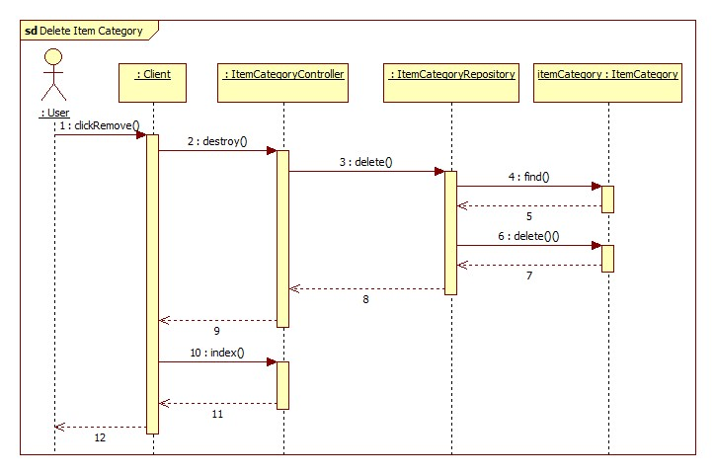

**Collaboration Diagram**

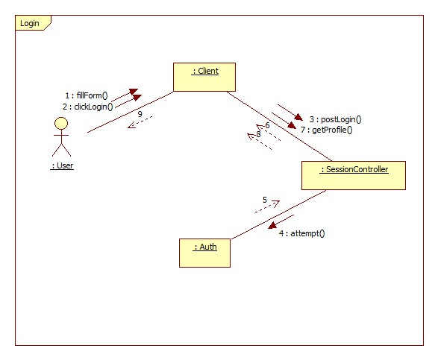

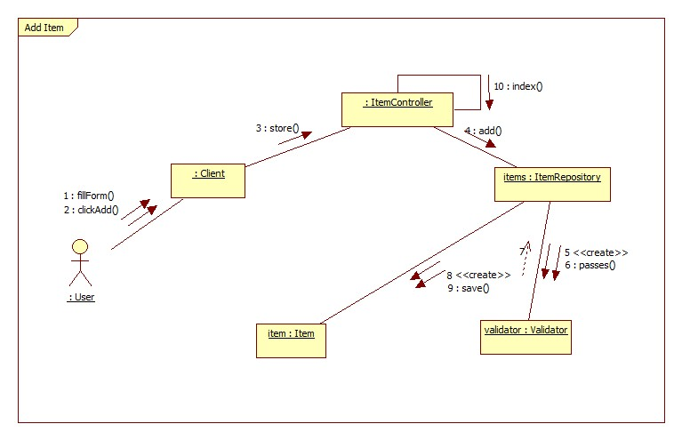

**Deployment Diagram**

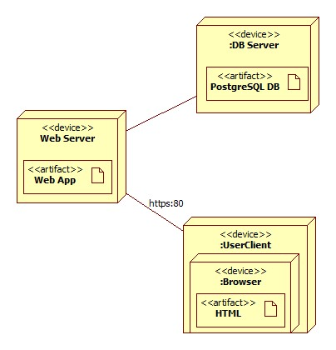

**System Architecture**

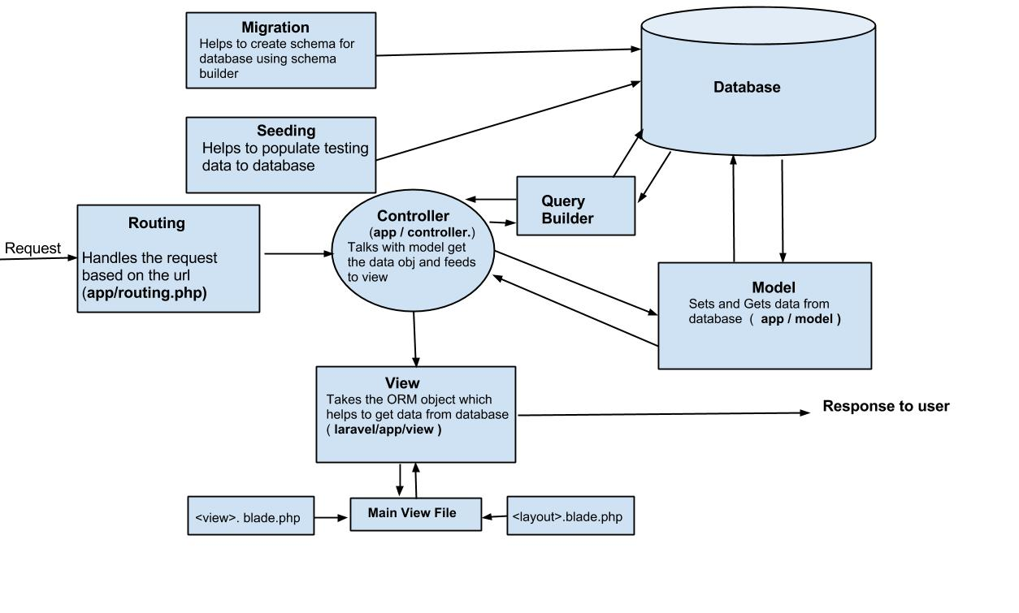

**Activity Diagram**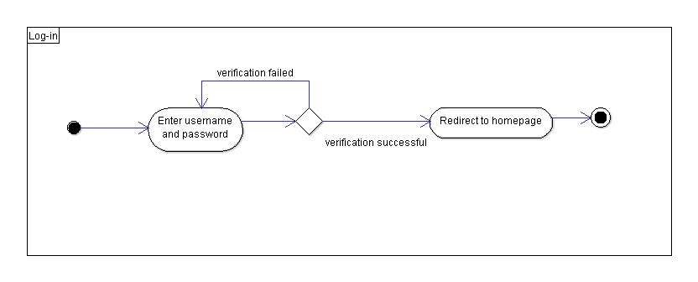

Figure 1. Log-in Class Diagram

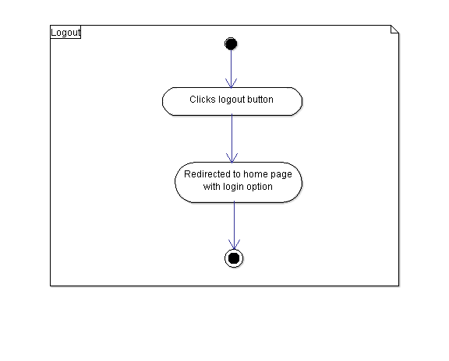

Figure 2. Logout Activity Diagram

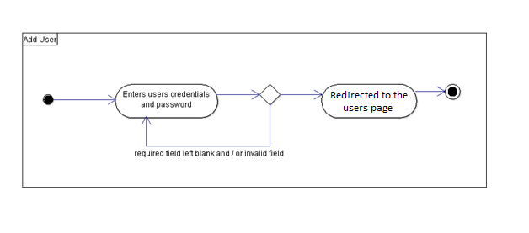

Figure 3. Add User Activity Diagram

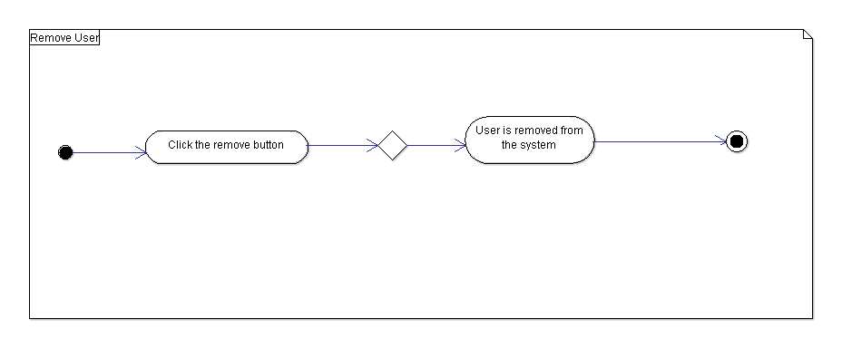

Figure 4. Remove User Activity Diagram

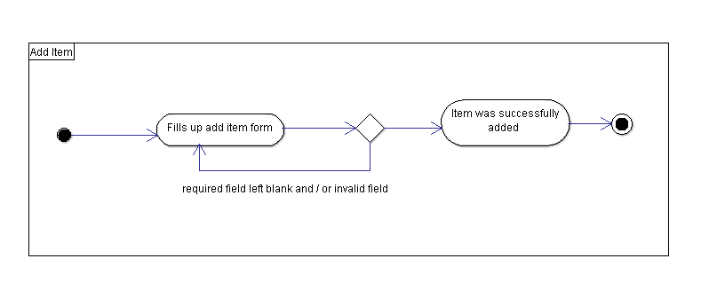

Figure 5. Add Item Activity Diagram

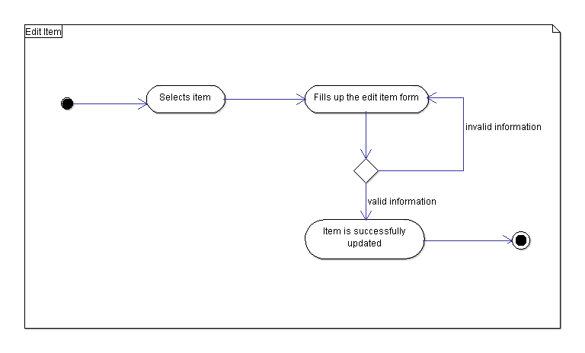

Figure 6. Edit Item Activity Diagram

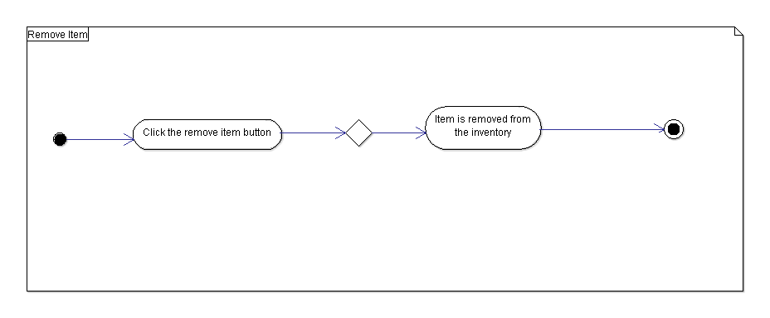

Figure 7. Remove Item Activity Diagram

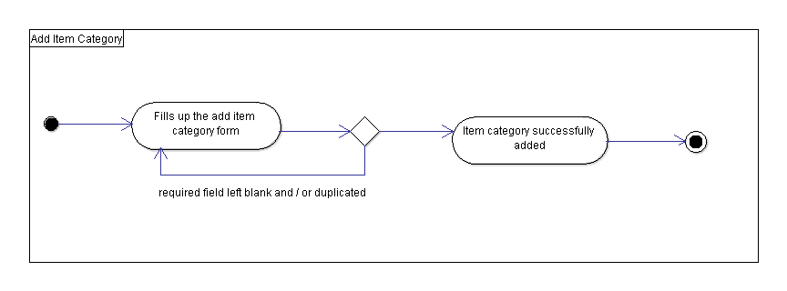

Figure 8. Add Item Category Activity Diagram

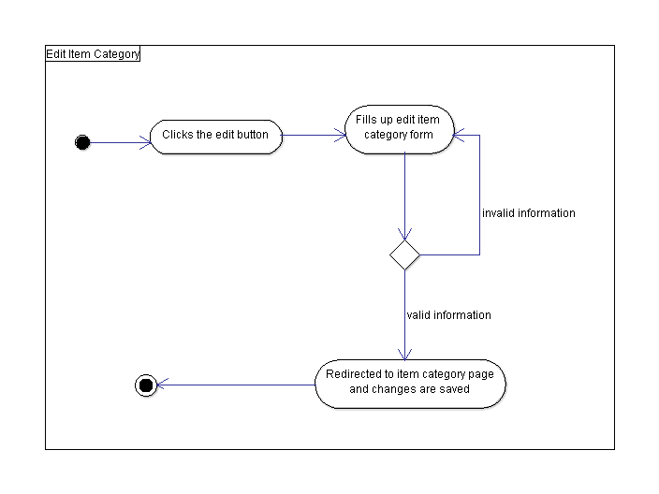

Figure 9. Edit Item Category Activity Diagram

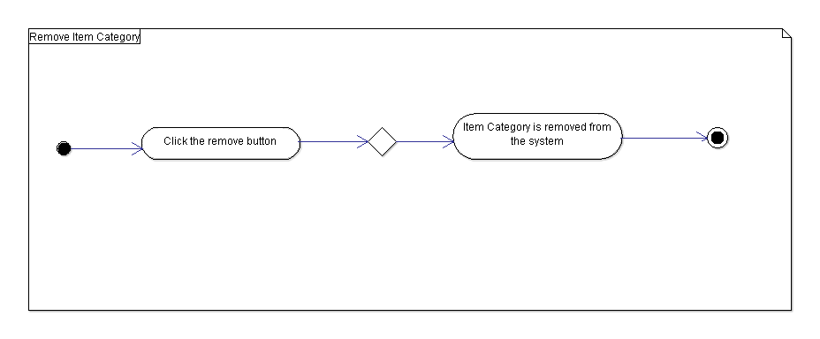

Figure 10. Remove Item Category Activity Diagram

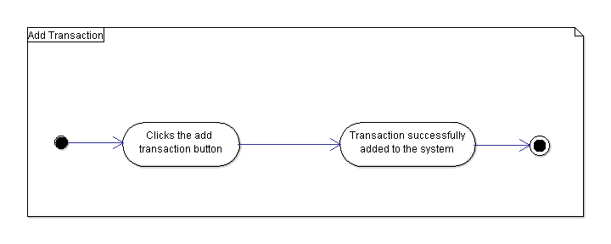

Figure 11. Add Transaction Activity Diagram

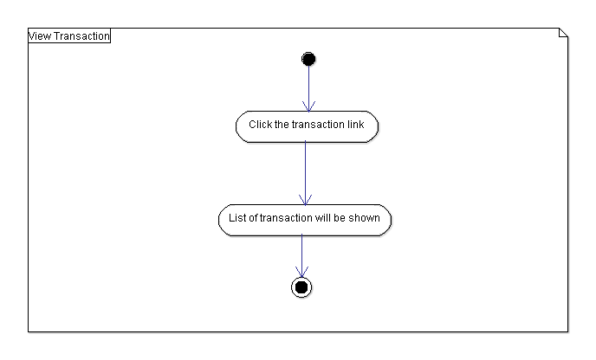

Figure 12. View Transaction Activity Diagram

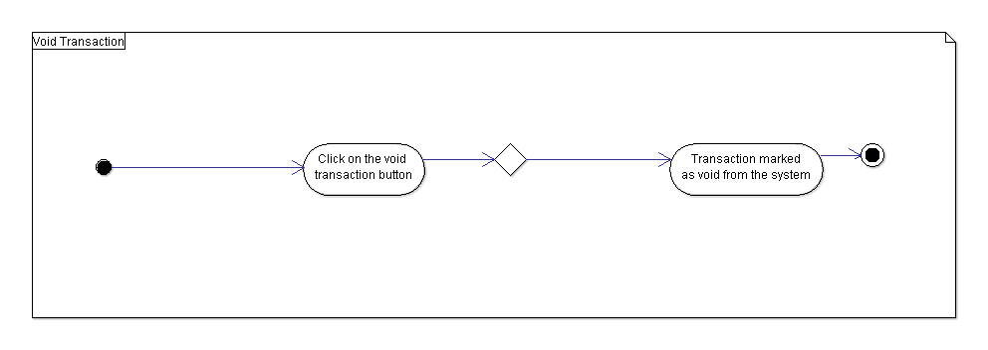

Figure 13. Void Transaction Activity Diagram

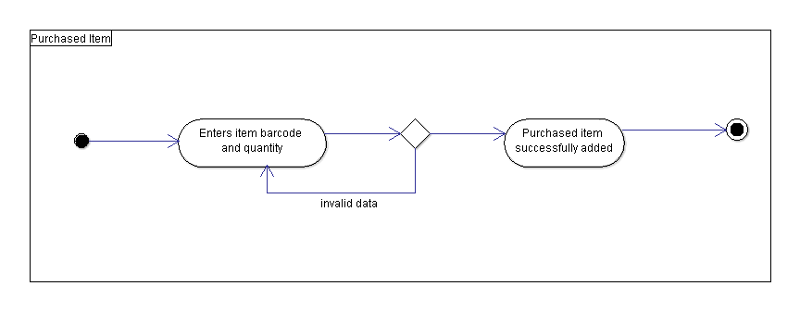

Figure 14. Purchased Item Activity Diagram

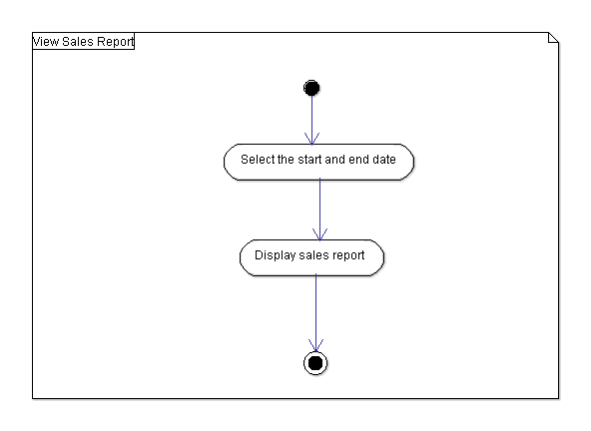

Figure 15. View Hourly Sales Report

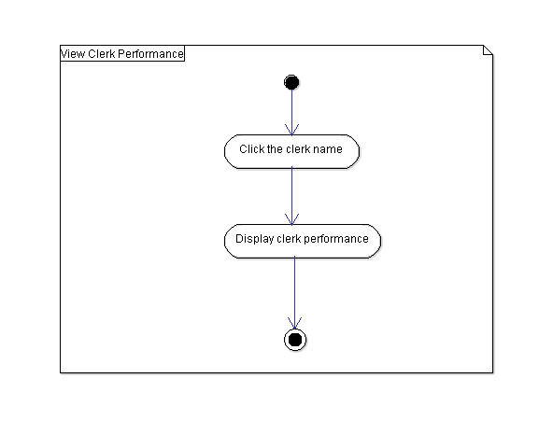

Figure 16. View Clerk Performance Report Activity Diagram

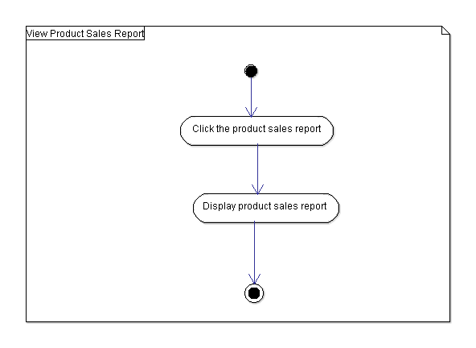

Figure 17. View Product Sales Report Activity Diagram